**IDEATION PHASE**

**BRAINSTORM & IDEA PRIORITIZATION**

|  |  |
| --- | --- |
| **DATE** | 03 October 2022 |
| **TEAM ID** | PNT2022TMID29591 |
| **PROJECT NAME** | Project – Personal Expense Tracker Application |
| **MAXIMUM MARKS** | 4 Marks |

**Brainstorm & Idea Prioritization:**

**PERSONAL EXPENSE TRACKER APPLICATION:**

Step-1: Team Gathering, Collaboration and Select the Problem Statement

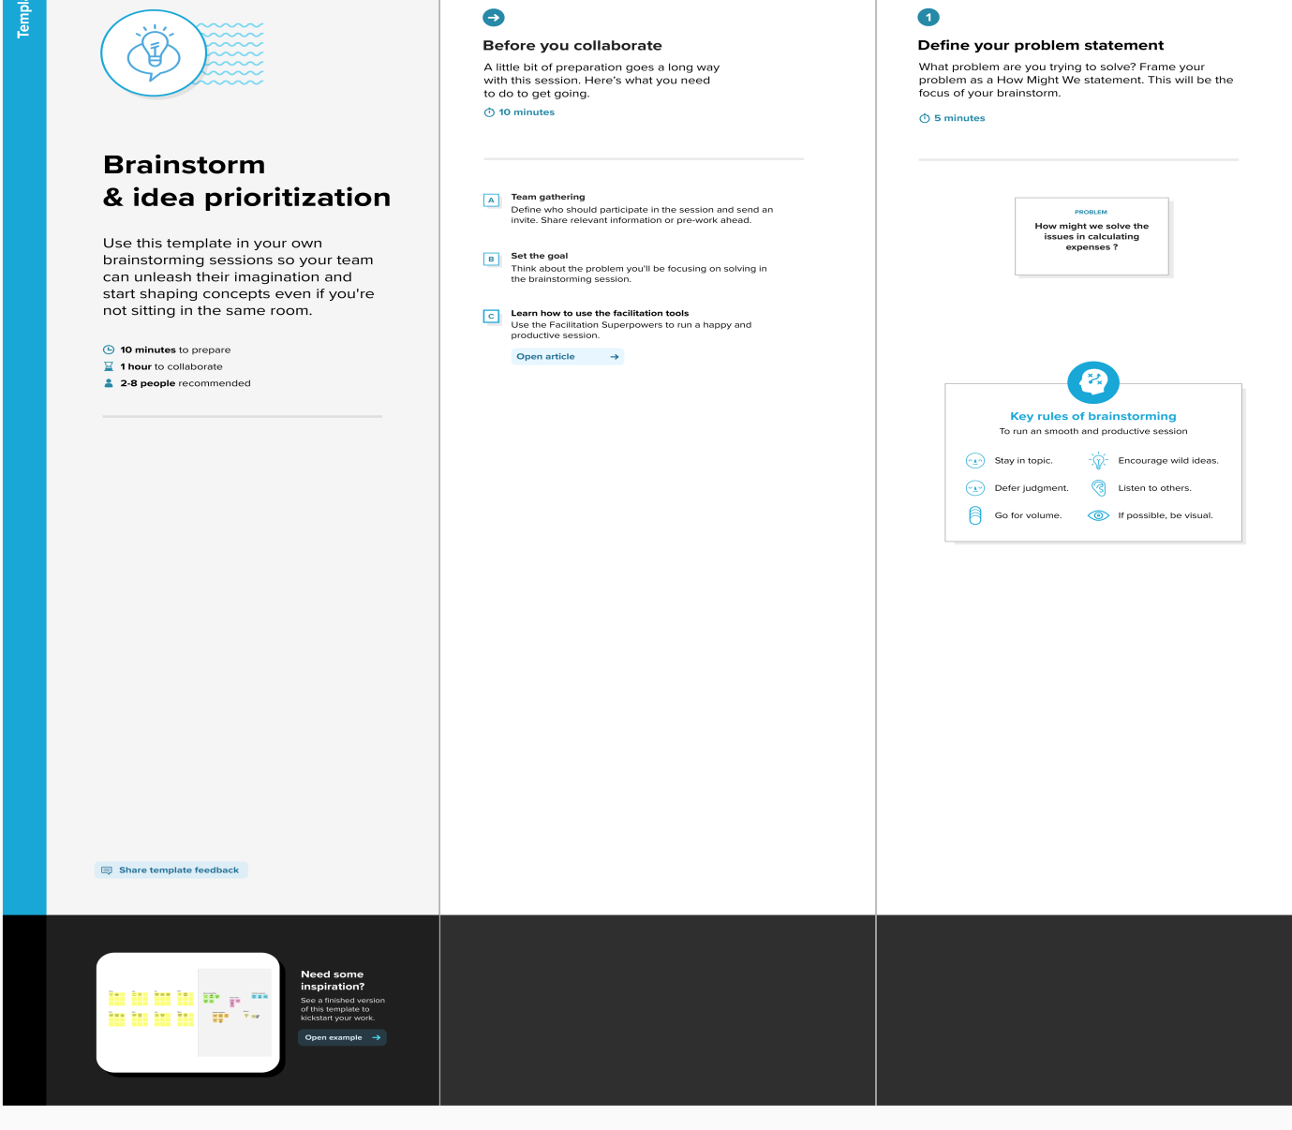

Step-2: Brainstorm, Idea Listing, and Grouping

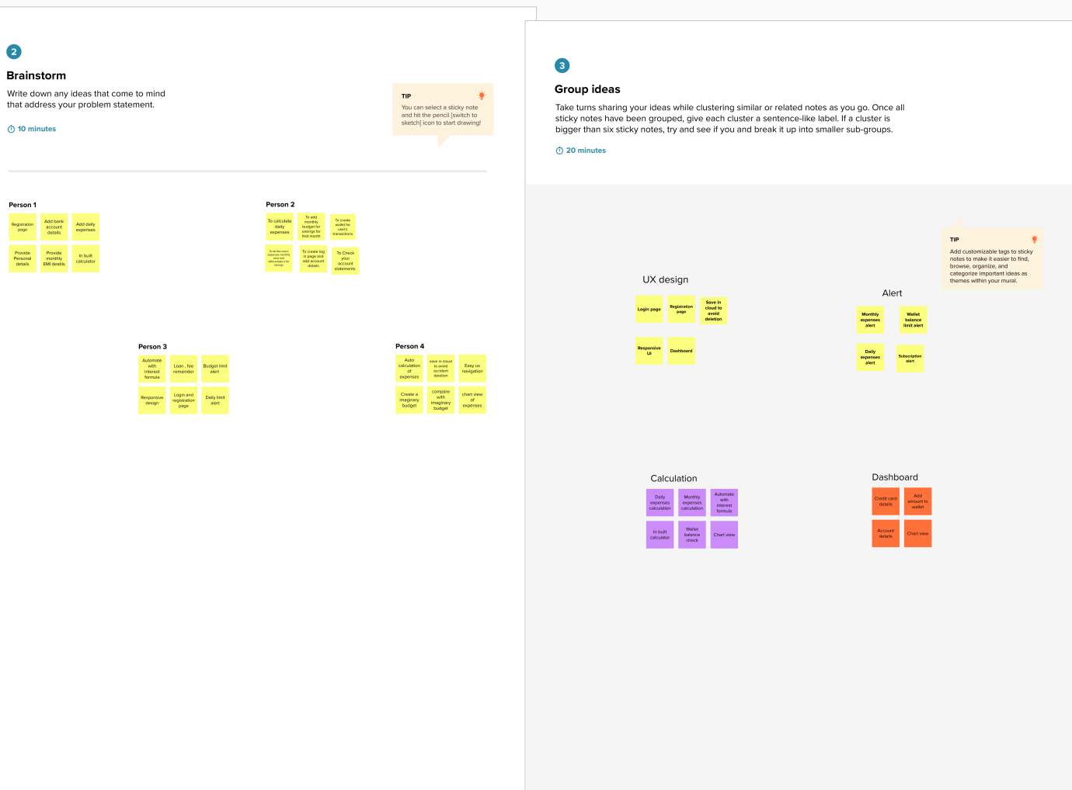

Step-3: Idea Prioritization